**A Start to MongoDB**

Its a open-source document Database that provides high performance,high availability and automatic scaling.  
It use the Not Only sql(i.e NOSQL), unlike sql it contains data of documents,graph store or column store.

As we know that the Mongo Db is an open source database it can be easily downloaded from mongodb’s website and further installed & set up in our local computer.

**Installing MonogoDB:**

Step1: Visit the [www.mongodb.com](http://www.mongodb.com) website  
Step2: Navigate to the “Products” sections , which you might see at the top of the website.  
Step3: Choose Community Edition and scroll down to see the download option.  
Step4: Choose the version and other features that match your need and click download.  
Step5: After download install the app with proper directories as per your requirement.

Step6: Download the MongoDB shell from the same website  
Step7: Set up the Directory to save your Data that you might create in the MongoDB.  
Step8: use command mongosh

Step9: now you are ready to use the Database

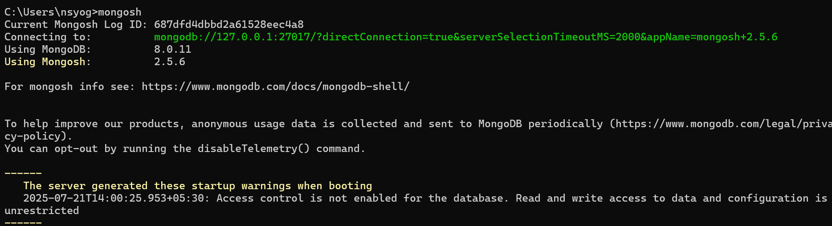

Use the command “show dbs” to view the existing databases in your mongo Db, also you can run the command “use <collection name>” this instantly creates a new collection  
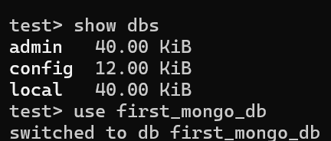

The data in mongodb is stored in the key value format. The tables that we use in sql don't exist here instead we have Collections which are similar to tables in sql. And in each table we insert rows , but here in each collections we insert documents.



